Source 1: Artwork  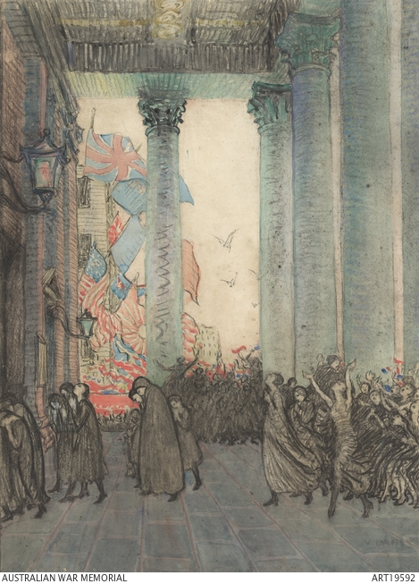  Vida Lahey, Rejoicing and remembrance, Armistice Day, London, 1918, 1924. https://www.awm.gov.au/collection/C186262  The painting depicts groups of women mourning and rejoicing at St Martin–in-the-Fields in Trafalgar Square, London, on Armistice Day, 11 November 1918. | Supports the proposition | Disagrees with the proposition

Source 2: The John Monash address, 26 November 1918  “We are faced with the problem of returning to Australia something like 200,000 individuals – comprising fighting men, munitions workers, and dependants (wives and children). The problem is not only how to return these people home to Australia in the most expeditious way, but also how to send them home in a condition – physically, mentally and morally – to take up their duties of citizenship with a minimum of delay, a minimum of difficulty and a minimum of hardship on the community and on the individual …  To do that we have to begin creating a morale throughout the AIF – a morale which, for want of a better word, I will call the “reconstruction morale” …  [A]t what rate shall we be able to send the men home? That depends on the shipping available, and there will be a very heavy demand by all nations, and for all purposes, on all available tonnage. That is an Imperial question; in fact, it is an international question. Great Britain must be prepared to take her share of tonnage, and the Shipping Control will allot certain proportions to Australia. Our position is likely to be relieved by the necessity … of bringing from Australia to England a great amount of wool, wheat and meat …  We have also to consider the capacity of Australia to absorb the men, for it would be a great disaster to have dumped in Australia 200,000 men who were either without employment themselves, or who would displace from employment those now employed …  What employment can be made available? We have Education, which will become part of the Demobilization Department, and will embrace:  - Commercial training.  - Preparing men for academic careers.  - University Courses.  - Professional or vocational training.  - Then Industrial employment comprising:  - Commercial employment …  - Scientific employment.  - New apprenticeship …  - Men who have broken their apprenticeship, or whose term of apprenticeship has been arrested, and who wish to continue in their trade.  - Wage-earning in a man’s present trade.  - Learning of new trades: this is of special importance to Australia, who in future intends to open up new industries, such as tin-plate making, ship building …  - Agricultural and rural industries of many kinds …  - Commonwealth workshops. The Commonwealth proposes to establish workshops, stores, etc. …  In conclusion, I ask for the utmost co-operation on the part of every officer and man; for what I am setting out to do is to be attempted in the common interests of ourselves, our men and our country.”  Address on Repatriation and demobilization by John Monash to divisional and brigade commanders on 26 November 1918, pp. 19–20, 24–25, 30. https://www.awm.gov.au/collection/C1341638 | Supports the proposition | Disagrees with the proposition

Source 3: Film  Repatriation film, Repatriation Department, Australia, c. 1918.https://www.awm.gov.au/collection/F00139 | Supports the proposition | Disagrees with the proposition

Source 4: Quote  “I know of at least one Aboriginal veteran of World War I who was not only denied his pay packet and his pension, but upon his return was given the very same rags he had been wearing the day he volunteered, and sent back to work on a station, as if the trenches and mud and the fighting had never happened.”  Gracelyn Smallwood, “The injustices of Queensland stolen wages”, in "Your say", Koori Mail, Issue 424, 23 April 2008, p. 25. | Supports the proposition | Disagrees with the proposition

Source 5: Quote  “Yet before the last veterans reached home the cheers were already dying away, and it soon became clear that the soldiers’ rewards would be less than had been promised during the war. Worse, ‘when I got home in 1919 Ex Diggers were singing for a living in the streets. Men without arms and legs, some in wheelchairs’ [H. Brewer reminiscing in 1967]. Probably that was not common in 1919, but it became more so with time, as stay-at-home Australians, weary of war, recoiling from its horror, and sickened by the number of victims, tried to forget those tragic years as quickly as possible. They could continue in ways and occupations they had not quit, and they easily resumed pleasures and relaxations the war had caused them to abandon. They were unable or unwilling to comprehend either the magnitude of the soldiers’ ordeal, or the force of the memories, good and bad, which separated returned men from others. They wanted a return to normalcy, and they expected returned men to show a similar desire.”  Bill Gammage, The broken years: Australian soldiers in the Great War, Melbourne University Publishing, Victoria, 2010, p. 275. | Supports the proposition | Disagrees with the proposition

Source 6: Photograph  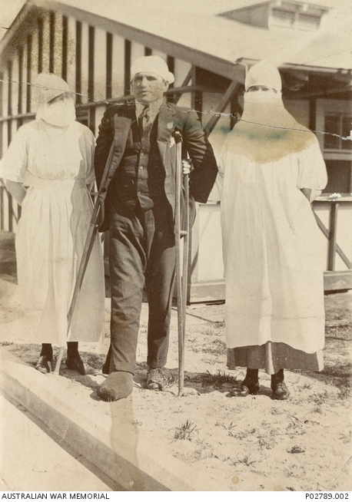  Voluntary Aid Detachment nurses M.M. Brooks and “Smithy” with a recovering soldier outside the flu ward at the Randwick Military Hospital, 1919. https://www.awm.gov.au/collection/C362415?image=1 | Supports the proposition | Disagrees with the proposition

Source 7: Statistical data on deaths in the Australian Imperial Force  Year From battle casualties From non-battle casualties Total Progressive total  1914 - 14 14 14  1915 7,819 655 8,474 8,488  1916 12,823 873 13,696 22,184  1917 20,628 1,108 21,736 43,920  1918 12,553 1,687 14,240 58,160  1919 27 597 624 58,784  1920 - 6 6 58,790  Totals 53,850 4,940 58,790 58,790  From A.G. Butler (ed.), Special problems and services, vol. III of The Official History of the Australian Army Medical Services, 1914–1918, Australian War Memorial, Melbourne, 1943, p. 900. | Supports the proposition | Disagrees with the proposition

Source 8: Photograph  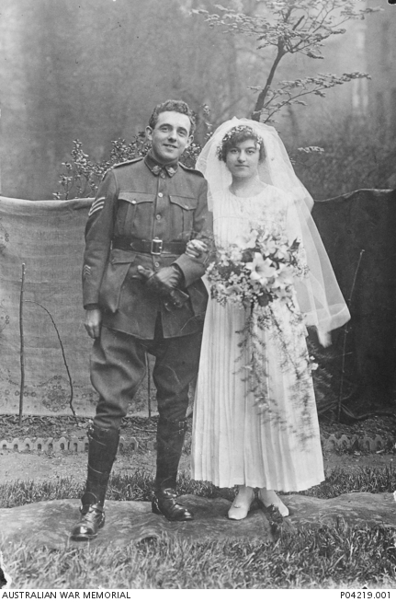  Sergeant James Matthews, 7th Battalion, and his British bride, Caroline Janetta (nee Huggett), on their wedding day in London, 13 April 1918. Matthews later returned to Australia with his wife on 25 February 1919. https://www.awm.gov.au/collection/C1028878 | Supports the proposition | Disagrees with the proposition

